Frontend Development with React.js Project Documentation format.

**Rhythmic Tunes: Your Melodic Companion**

# 1. Introduction

**Project Title: Rhythmic Tunes: Your Melodic Companion**

Team Members: 4

Team Leader Name: Suriya K

Team Member Name: Subash I

Team Member Name: Sivanesh S

Team Member Name: SelvaGanapathi M

Team Member Mail Id: [ksuriyamsdgk@gmail.com](mailto:ksuriyamsdgk@gmail.com)

Team Member Mail Id: [phycoodove@gmail.com](mailto:phycoodove@gmail.com)

Team Member Mail Id: [sivaneshselvaraj.2007@gmail.com](mailto:sivaneshselvaraj.2007@gmail.com)

Team Member Mail Id: [selvaganapathicaptan@gmail.com](mailto:selvaganapathicaptan@gmail.com)

# 2. Project Overview

**Purpose:**

**Rhythmic Tunes is a modern music streaming application designed to offer users an immersive listening experience. It provides a vast collection of songs, playlists, and personalized recommendations. The app ensures a seamless interface for browsing, discovering, and enjoying music.**

* **Features**:
* **Browse Songs by Genre, Artist, or Album**
* **Personalized Playlist Creation**
* **Search Functionality with Real-Time Suggestions**
* **Media Player with Play/Pause, Next/Previous, and Volume Control**
* **Bookmark Feature for Saving Favourite Tracks**
* **Light/Dark Mode for Improved User Experience**
* **Responsive Design for Desktop and Mobile Devices**

# 3. Architecture

* **Component Structure:**
* **App.js Root component managing layout and routing**
* **Header.js Navigation bar with search functionality**
* **SongList.js Displays a list of available songs**
* **SongCard.js Individual card showing song details and controls**
* **Playlist.js Manages user-created playlists**
* **MediaPlayer.js Provides audio playback controls**
* **Footer.js-Displays copyright and app links**
* **State Management**

**Context API – Used for managing global states such as theme preferences, playlist data, and bookmarked songs**

* **Routing:**

**React Router- Implemented for seamless navigation between music categories, playlist views, and song details**

# 4. Setup Instructions

* **Prerequisites:**
* **Node.js (v18 or higher)**
* **npm or yarn**
* **Installation:**

1. **Clone the Repository:**

‘**’’Bash**

Git clone <https://github.com/darunraj0071/rhythmic-tunes.git>

**Cd rhythmic-tunes**

‘’’

1. **Install Dependencies**:

**‘’’Bash**

**npm install**

**‘’’**

3. **Create 'env' file (for API keys or environment variables):**

‘**’’env**

**REACT_APP_MUSIC_API_KEY=your_api_key_here**

**‘’’**

4. **Run the Application:**

‘**’’bash**

**npm start**

**‘’’**

# 5. Folder Structure

**/src**

**/components**

1. **Header.js**
2. **SongList.js**
3. **SongCard.js**
4. **Playlist.js**
5. **MediaPlayer.js**
6. **Footer.js**

/**pages**

1. **Home.js**
2. **Discover.js**
3. **Playlists.js**
4. **Favorites.js**

**/assets**

1. **Images**
2. **icons**
3. **styles**

**/utils**

1. **api.js**
2. **helpers.js**
3. **constants.js**
4. **App.js**
5. **Index.js**

# 6. Running the Application

* **Frontend Server Command:**

‘’’Bash

npm start

‘’’

# 7. Component Documentation

* **Key Components:**
* **Header**: Provides navigation, search functionality, and theme toggling
* **Song List**: Displays categorized or searched songs in a structured format
* **Song Card**: Displays individual song details with play/pause control
* **Media Player:** Controls audio playback, volume, and track navigation
* **Reusable Components:**
* **Button Component**: Used for actions like “Play,” “Pause,” or “Add to Playlist”
* **Modal Component**: Displays song details or playlist creation forms

# 8. State Management

* **Global State:** Managed via Context API for bookmarks, playlists, and theme control
* **Local State:** Managed using React’s ‘usestate()` for track progress, user interactions, and dynamic updates

# 9. User Interface

* **Clean, minimalistic Ul designed for seamless navigation**
* **Fully responsive layout with smooth transitions**
* **Light/Dark mode toggle for personalized visual comfort**

# 10. Styling

* **CSS Frameworks/Libraries:**
* **Tailwind CSS-**Used for fast and modern UI design
* **Theming:**
* **Integrated theme switcher for enhanced user experience**

# 11. Testing

* **Testing Strategy:**
* **Jest for unit testing**
* **React Testing Library for comprehensive component testing**
* **Code Coverage**
* **Ensured high code coverage with Jest reports**

# 12. Screenshots or Demo

# Screenshots:

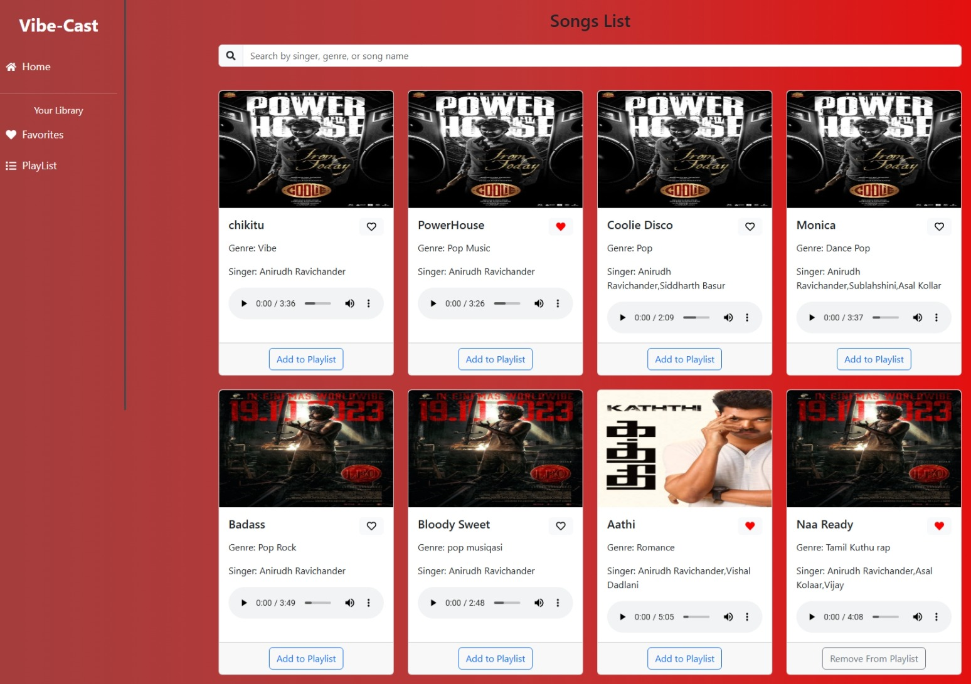

# **Favourites**

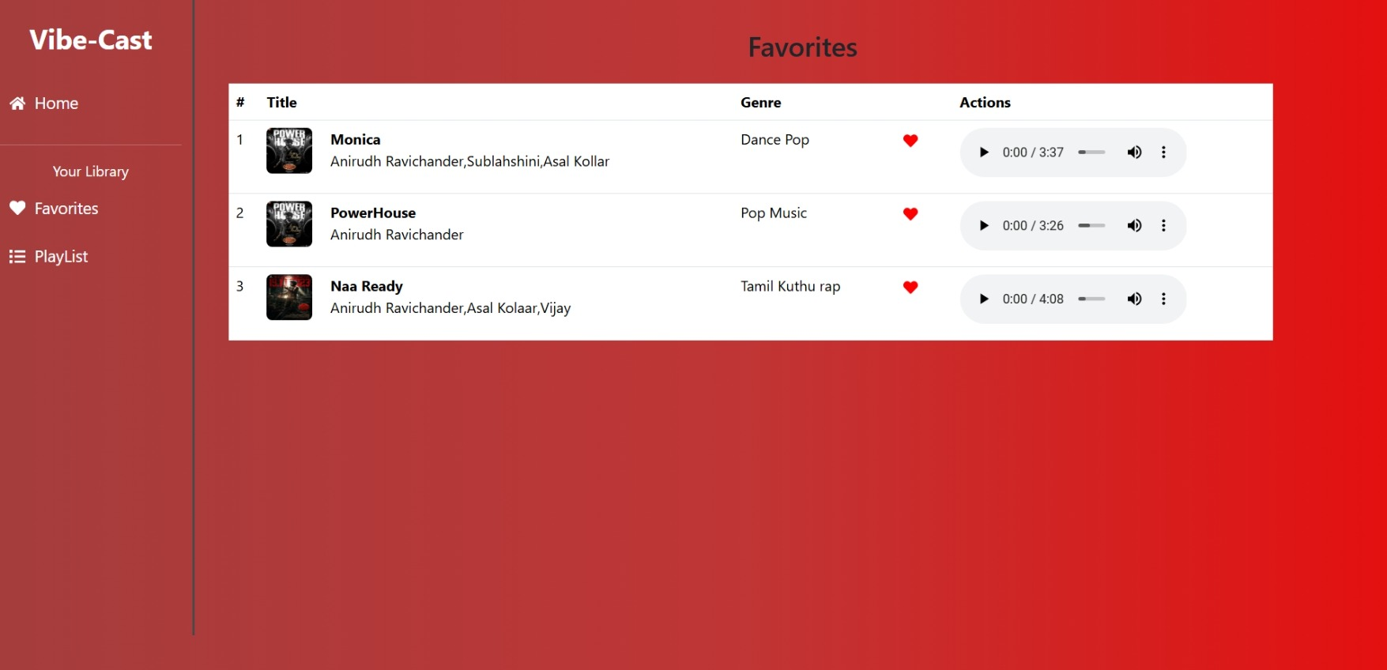

# Play List

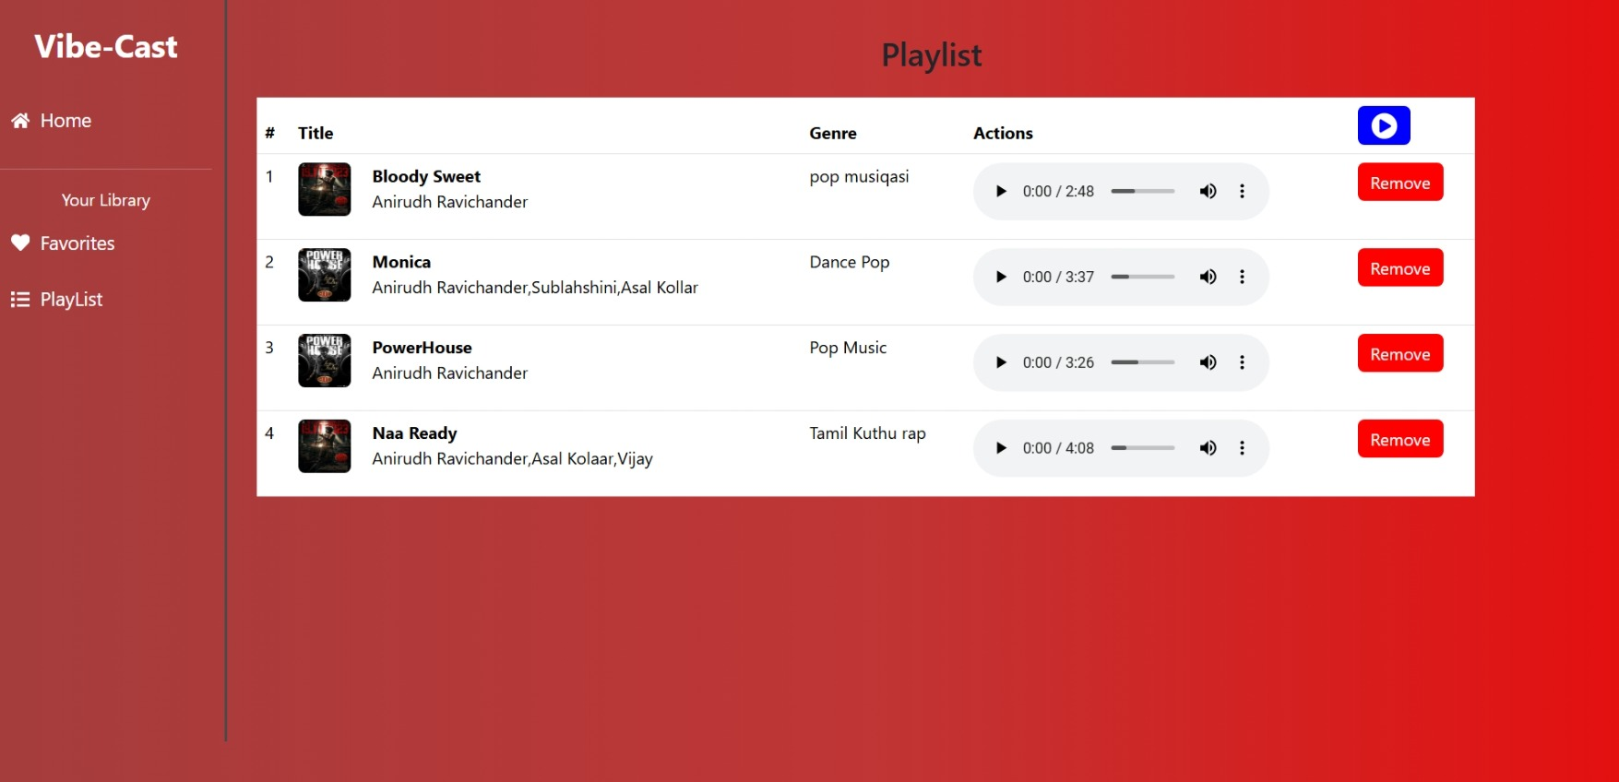

# 13. Known Issues

* **Occasional delays in song loading due to API limits**
* **Playlist feature may require additional optimization for large data sets**

# 14. Future Enhancements

* **Implement User Authentication for personalized playlists**
* **Introduce Podcast and Radio Streaming Integration**
* **Social Sharing Feature for tracks and playlists**
* **Offline Mode for saved playlists without an internet connection**

# **Conclusion**

**Rhythmic Tunes – Your Melodic Companion – is designed to create a complete and engaging music experience. By offering smooth navigation, personalized playlists, and user-friendly controls, it becomes more than just a music player; it becomes a trusted partner for every mood and occasion. As technology and music evolve, Rhythmic Tunes will continue to enhance its features, delivering harmony, joy, and a deeper connection between listeners and the music they love.**